Kinematics and dynamic analysis of a 3-Axis spatial robot manipulator

Priyabrata Chattopadhyay^{1*}, AtanuMaity¹, Sanjay Ghoshal²

¹Scientist,CSIR-Central mechanical engineering research institute, ISM-Dhanbad²Associate Professor, CSIR-Central mechanical engineering research institute, ISM-Dhanbad

Abstract
The idea behind the development of 3-axis (3-DOF) manipulator is to build a serial link mechanism, which would yield structural rigidity and balanced load distribution. The CAD/CAM tools have been used to design this robot manipulator. All design issues which addresses above objectives are analyzed from the simulation point of view. Trajectory planning plays an important role in the operation of robot manipulators. Trajectory of a manipulator is either defined in joint space or in Cartesian space. The path planning of this experimental manipulator using joint space have been investigated and presented in this paper. The aim is to generate a trajectory from start to finish that satisfies objectives, such as minimum traveling distance, minimum time of travel, less energy consumption while satisfying the robot’s kinematics and dynamics. Both kinematics and dynamic model formulations used for the design of robot manipulator have been discussed. Several software applications have been used to model and analyze the manipulator parts. The analysis of both kinematics and dynamics aspects has been carried out in dynamic simulation software. Stress and deflection analysis of each link of the manipulator assembly has been done in simulated environment. Data obtained from the simulation analysis have been used for finalization of geometric parameters such as payload carrying capacity, speed of each link, minimum weight, resolution, repeatability as well as rigidity.Though the exercise has been done on a lab-scale prototype, knowledge so generated can easily be implemented on a fully functional manipulator.
Keywords: 3D solid modeling, Accuracy, Kinematics and dynamic simulation, Mathematical formulation, Trajectory planning
Corresponding Authors: p_chattopadhyay@cmeri.res.in^{1*}, maity@cmeri.res.in & sanjay_ghoshal@yahoo.co.in
1. Introduction
Robotic Manipulators have been designed with mimic to human hand mobility. CAE methods would augment the design process of robot manipulator since the robot design consists with various parameters. In general robot manipulators are complex mechanical devices that are designed for the specific applications. Design of robot typically has begun with the selection of a kinematics (i.e. forward and inverse kinematics) formulation. Kinematic formulation has been used to meet certain geometric goals such as trajectory planning, 3Dworkspace, dexterity, or singularity avoidance. Kinematic design was first described by Denavit-Hartenberg (D-H) parameters (Hartenberg and Denavit, 1964) and the D-H convention (Craig, 1986) [1]. Since then D-H convention has played significant role during kinematics formulation.Next focus during design of manipulatorwas to assign mass and motion control components to form manipulator’s structure. Here structural components would satisfy the kinematic framework as well as performance requirements such as payload, speed, accuracy and deflection. Therefore application of CAE has found suitable to satisfy design procedure. CAE techniques for design of robotic manipulator have been used widely. Design procedure of robot was studied by Thomson (1984) [2]. Driving methodology of industrial robot was discussed by Vukobratovic et al. and implementation of CAD systems during advanced robot design were also discussed (2002) [3]. Parallel structure robotic hand having similarity with SCARA (Selective compliance assembly robot) robot, had similar functionality or geometry with the serial link open structure was also suggested by Nasiri (2004) [4]. A integration of CAD based approach was implemented by Clark & Lin in 2007 during verification of robot mechanism [5]. Robotic micro-manipulator was developed by C-S Han, A. E. Traver and D Tesar with help of CAD/CAM technique during model preparation, analysis and manufacturing micromanipulator components [6]. Karim Abdel-Malek and Burton Paul [7] had developed criteria for the design of six serial link robot manipulator arms for a high stiffness to weight ratio. Optimization of a 5-axis RHINO robot with the help of CAD system was described by Kunwoo Lee [8]. Trajectory outcome of a planar two-link flexible robot manipulator was studied by using integrated computer-aided design/analysis (CAD/CAE) procedures. Velocities, accelerations of each links, joint forces and driving torques were calculated through rigid body dynamics with known payload [9]. Inverse kinematic model of 3-DOF industrial robot manipulator was prepared through Denavit -Hartenberg (D-H) parameters. Then genetic algorithm (GA) was utilized for optimizing the model to improve efficiency and remove considerable error [10]. Integrated application of CAD/CAM/CAE and rapid prototyping (RP) was utilized during development of structure of biped humanoid robot, Bonobo, which include relatively low cost and time [11]. Advanced Servo Manipulator (ASM), based on in-house mechanical design and indigenous drives and controllers had been developed by BARC (Bhava atomic research centre). The manipulator was developed with in-house mechanical design and indigenous control hardware and software with digitally controlled force sensor [12]. Drive train configuration arrangement of gear coupled manipulators was described by Dar zen chen in 1997. Here gear coupled manipulator was shown as equivalent open-loop chain (EOLC) [13].
In this paper, a 3-Axis articulated type robot manipulator has been designed with application of CAD-CAM techniqueto develop a complete 3D model of robot mechanical subsystem. This spatial model contains important information about geometric shape, mass properties, mechanism number parts and degrees of freedom. A suitable CAE tool system has been used to check whether there were interferences occurred in assembly and dynamic analysis tool has beenare incorporated to check to mechanism functionality for verification before the final prototype production. A simplified model of robot manipulator has been analyzed (both static and kinematic) to reduce computational load. After a preparation of the robot design assembly (define material of all components, datum points, co-ordinate systems, joint axis, drivers or loads and measures) manipulator virtual model has been tested in simulated environment. Applications of the motion simulation software were effective to gather information about the functionality of virtual 3D model of robot manipulator. The implementation of friction, contacts or damping into virtual model might be come up into virtual model to make it real product and gives assumption that themotion analysis results may have significant result.
2. Mathematical formulation and kinematic analysis:
Two basic factors for manipulator design are the kinematic configuration and the drive power for each link. A robot manipulator should have a full six degrees of freedom to able to work in 75% defined workspace. In order to reduce mechanical complexity, wrist joint configuration has been deducted and CAE analysis of a 3 axis spatial robot manipulator has been observed. This manipulator consist of 3-degree of freedom (DOF) with three non-intersecting revolute joints. A simple analytic (geometric) inverse kinematics solution has been used for desired manipulator motion and that would be allowed to develop a smooth trajectory for each link motion.With this observation of path, the kinematic configuration was finalizedand has been implemented.Kinematic formulation of 3-axis robot manipulator consists of two parts forward and inverse kinematics. The former is to develop the last link position and orientation when assigning the joint variable vector ԛ, while latter is to find ԛ when giving the desired position and orientation. Forward kinematics approach has been considered as more convenient approach due to its flexibility for various trajectory paths planning with fixed position and orientation of the end-effector.Parameters of the manipulator’s kinematic model have been listed in Table1. The position and orientation of the last link (end-effecter), for the given joint variable vector q =[π/4 -3π/4 π/2]^{T} and link parameters d₁=175 mm,a₂=a₃=100 mm have also been tabulated in Table 2.
Table 1 Table 2
Kinematic model parameters of RRR manipulator End-effector position and orientation
T_{E}==

Link | α_{i-1} | a_{i-1} | d_{i} | θ_{i}
1 | 0 | 0 | 175 | θ₁
2 | -π/2 | 100 | 0 | θ₂
3 | 0 | 100 | 0 | θ₃

Geometric solution has been adopted to explore the inverse kinematics. Figure 1.below have shown the position and orientation of robot manipulator.
θ₃

θ₂

θ₁

θ_{i}

(a) (b)

Figure 1(a) and (b): Projection of robot manipulator on x₀-y₀ plane for geometric solution.

By projecting the robot manipulator on x-y plane, the value of θ₁ had been found as 45°, 135°. Similarly by projecting the robot on projection plane θ₂ and θ₃ would be obtained as 135° or 45° be found by geometric projection.
3. System Design
In this paper, manipulator has been designed for performing point to point motion within a 3D volume workspace. The base joint requires higher torque, which is supposed to be a shoulder joint and does not contribute to gravity loads. Being housing of motors, gears, bearing, and electrical accessories, the weight of base joint was increased and its shape was designed with higher factor of safety. As a result, shoulder joint was loaded heavily also. The type and size each link robot had been calculated according to type and size of the link drive mechanism has been chosen. . Computer interface programming was easy, as the each link was directly coupled with electrical motor. As the dimension and load carrying capability of robot manipulator are in laboratory scale, manipulator would not require high power. DC servo motors may be obvious choice for drive mechanism.
3.1 Structural analysis
Structural design concentrated on providing maximum stiffness (minimum deflection) consistent with light weight.In this study, CAD software is used for modeling and static analyzing. A 3-axis robot with minimum payload capacity, light weight and smooth reachability in 3D space has been preferred. Static simulation of the robot has been carried out with Payload 1 kg while also considering the possible weight at 2nd and 3rd links (approx.0.5 kg). In addition, dimensions of the robot are calculated while considering the workspace operations. The base joint is rotated with respect to base almost with 360°rotation. The base link or first link is a cylindrical body part. A housing, bearing, gear are designed in order to transfer motion from the mounted motor to the base link. Gear and bearings are directly coupled with base link. After that, second link (100 mm length between joint axes) and third link (100 mm length between joint axes) are designed. The second motor and its bearing and gears are mounted at the front end of the base link. Second link is directly coupled with the first link. 3D model assembly and sectional view of the robot manipulator model was illustrated in Figure 2.
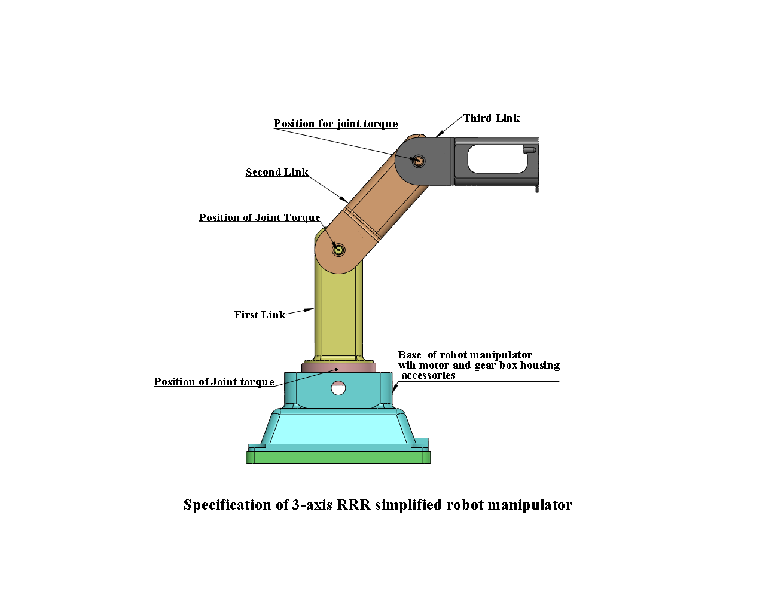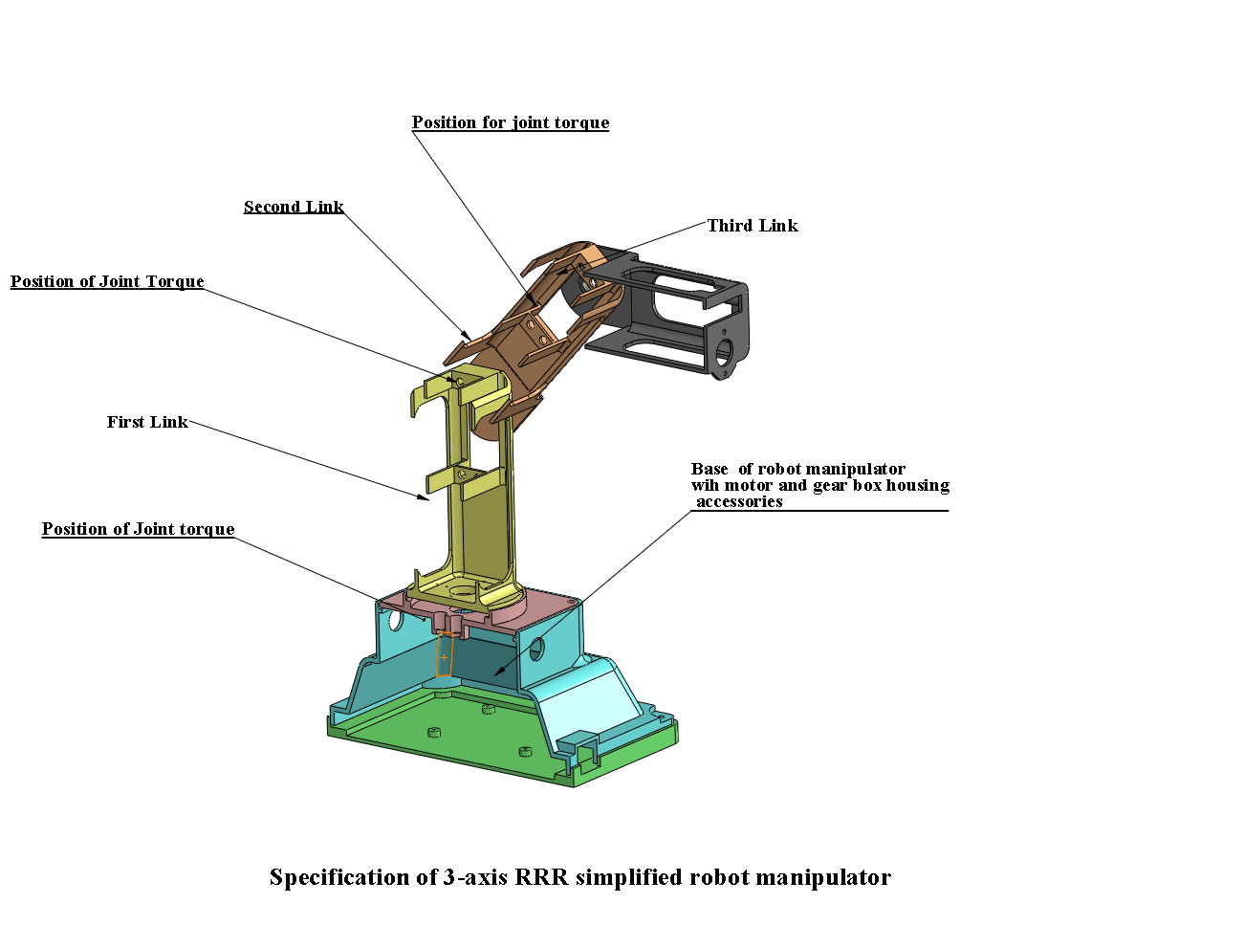

Figure 2. Simplified RRR robot manipulator
Primary considerations during manipulator design were to make the manipulator light enough with minimum inertia of the manipulator parts and accuracy.The robot manipulator which had 3-DOF three degrees of freedom and 1 kg payload was considered in this design study. It was intended that the robot would have174 mm maximum reach distance and 400mm/s maximum end point velocity. The workspace of the robot manipulator is obtained from inverse kinematic solution. Using CAE, a preliminary three dimensional design of the manipulator was created (Figure.2) to study its behavior. Simulation tools were selected to perform the static and dynamic analysis of the robot. From simulation, details like physical structure and dimensional and drive mechanism design analysis has been done. Rigidity of the robot was determined using the results of the maximum end point displacement and natural frequencies of the robot at pre-defined set ofposition and orientation of robot manipulator. Natural frequencies are calculated as the point masses which are equivalent to masses of the associated motors and gears are added on the robot model. Aluminum materials are assigned to the whole robot parts except gears, bearing, and motor due to lightness. Acceleration due to gravity (g) was taken into consideration with a value of -9.81 m/sec². As seen from the Figure 3, maximum displacement of the end point is 0.5 mm. Axes are locked in the static analysis. The manipulator model has been analyzed for maximum distance from first axis. During static analysis, von misses stress development, displacement and strain distribution had been analyzed. So stress distribution on the parts of the robot is investigated for different configurations. Static displacement and stress distribution for the particular position and orientation of the robot are shown in Figure. 3(a) and (b). Structural displacements of robot under natural frequency were also shown in Figure 4(a), (b) and (c) for first three mode shapes. General results of static analysis was tabulated in Table1. As designed aim was to fix maximum displacement at the tip equal or lower than 0.5 mm, it was pursuant with design safety.
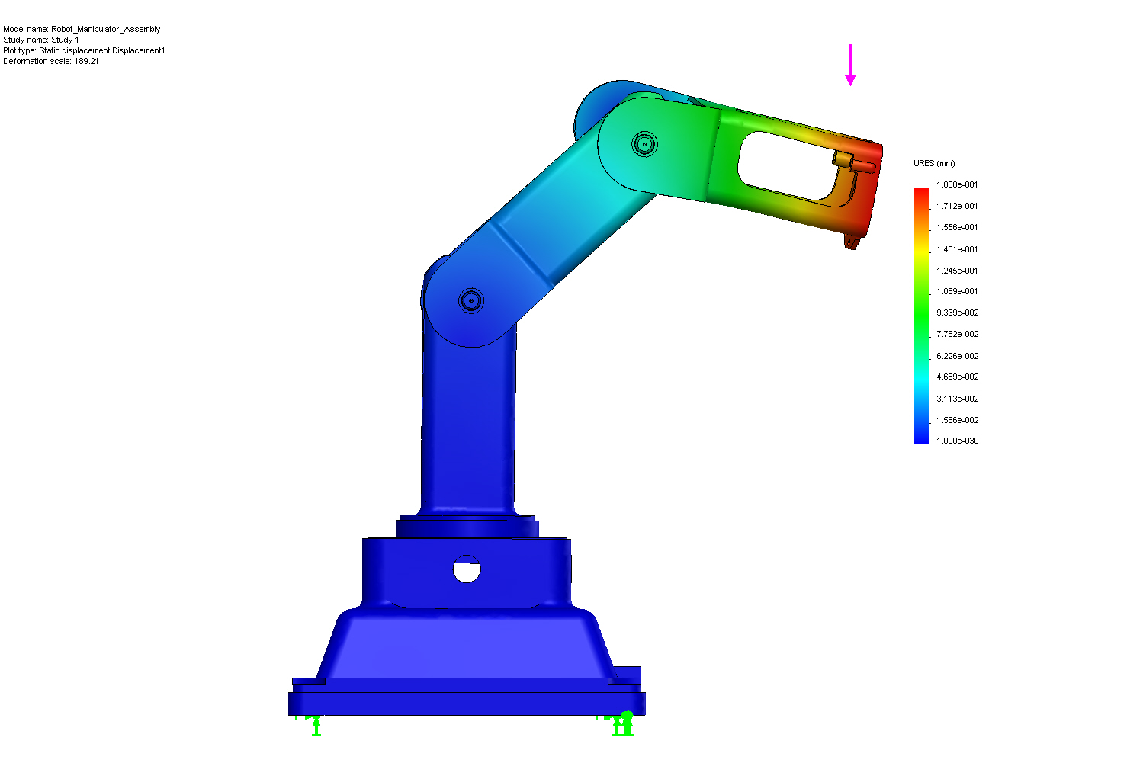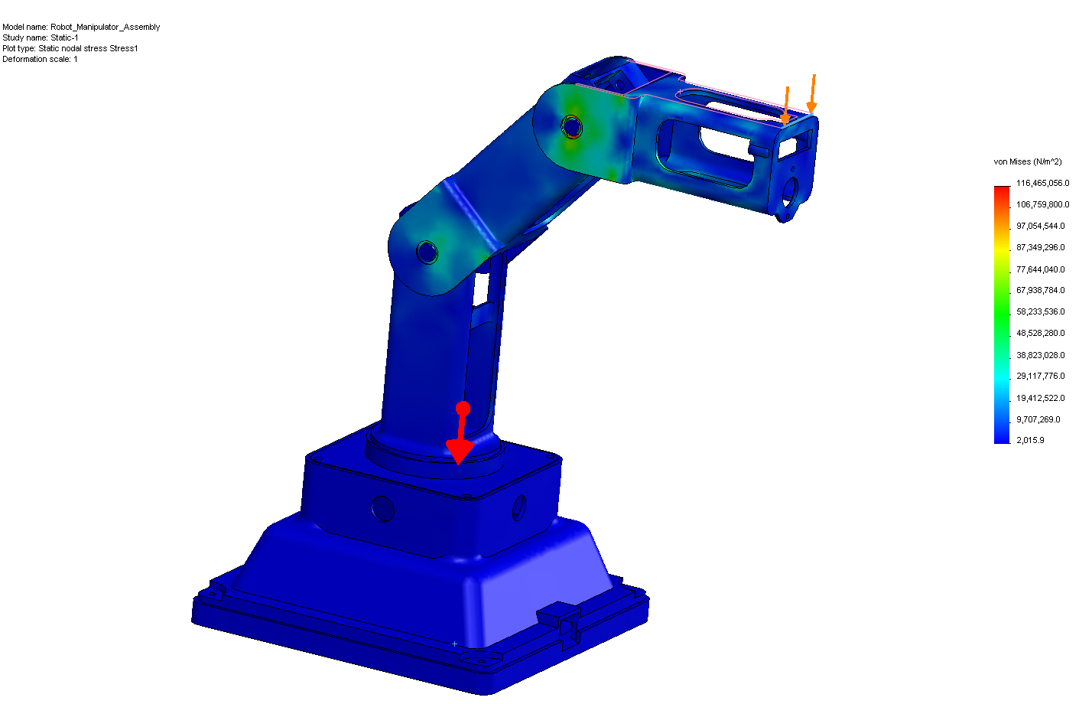

(a) (b)
Figure. 3(a) and (b): Static displacement and stress distribution of manipulator
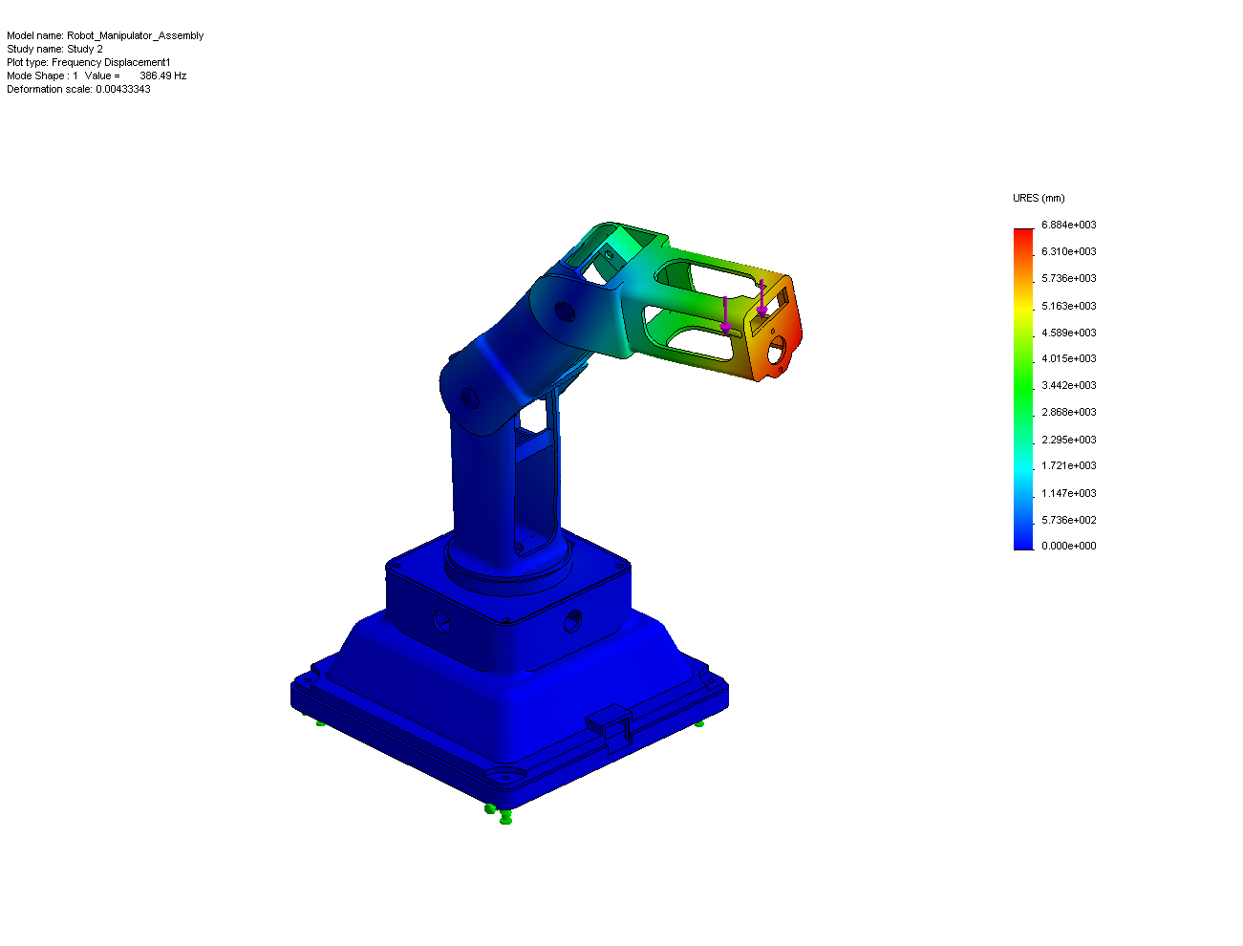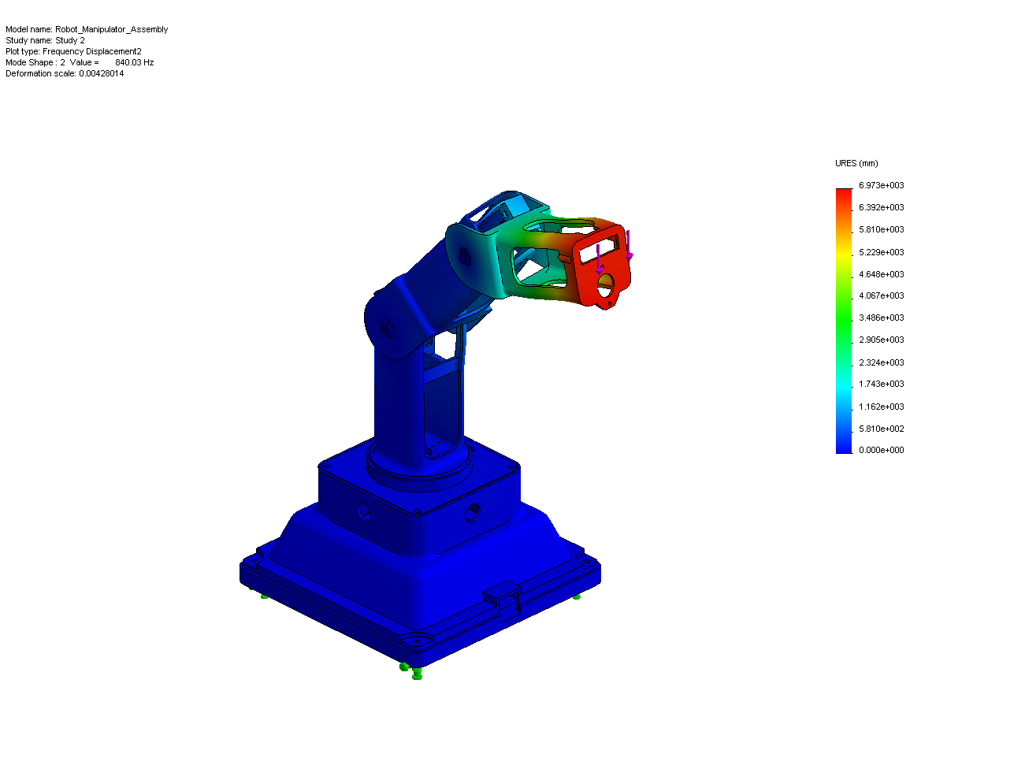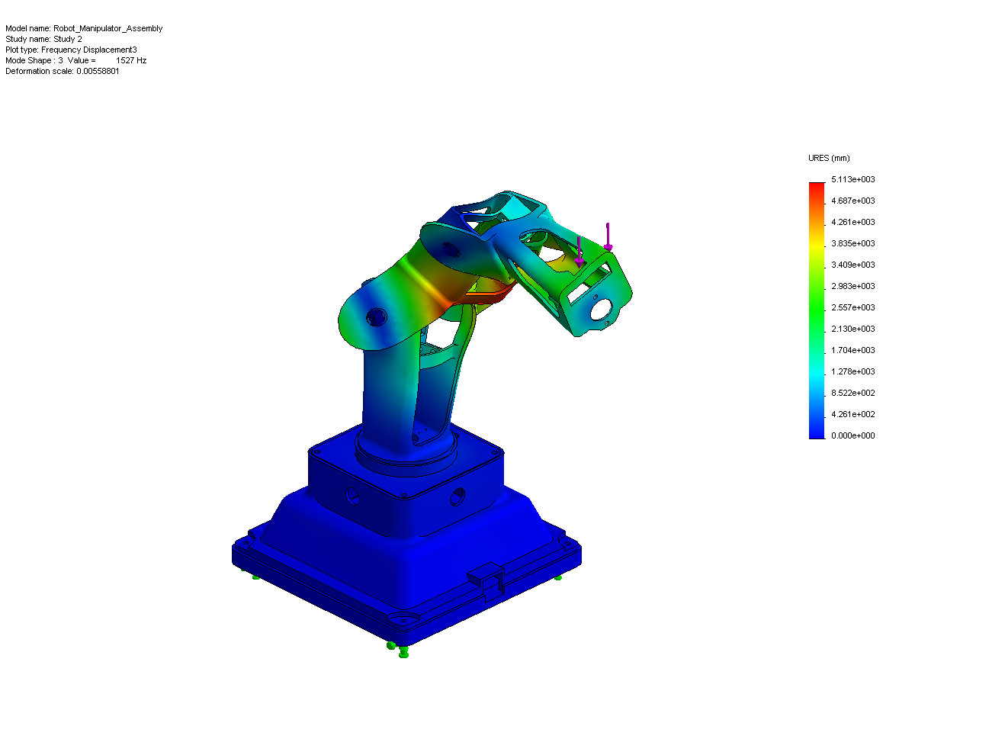

(a) (b) (c)
Figure 4(a), (b) and (c): Displacement of robot manipulator during its natural frequency of (a) first mode shape 1, (b) second mode shape and (c) third mode shape 3.
Table 1
Maximum displacement of the end point (mm) | 0.5
Maximum von-mises stress (N/m²) | 2.40e+007
First Natural Frequency (Hz) | 7.497
Second Natural Frequency (Hz) | 7.449
Third Natural Frequency (Hz) | 8.698

3.2 Dynamic analysis
Evaluation studies of static analysis are finished after these results. Kinematic analyses of the robot manipulator are carried out by dynamic simulation software. In order to place a motor for each revolute joint, motion command was applied to each joint of the robot. Angular velocities at each link joint interface were measured. Selection of motors and corresponding gear ratio would be designed with help of this measured angular velocity. Desired end point velocity had been chosen as 400 mm/s for this robot. Kinematic analyses are performed for different trajectories necessary. Initial and final positions of the robot end point on a sample trajectory are shown in Figure 4.The end point velocity profile is as shown in Figure 5.Angular velocities of the robot axes are calculated according to desired end point velocity. These angular velocities are shown in Figure 4.
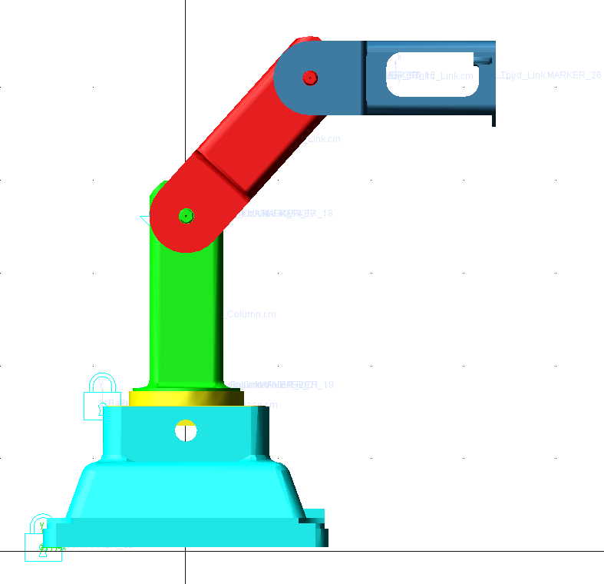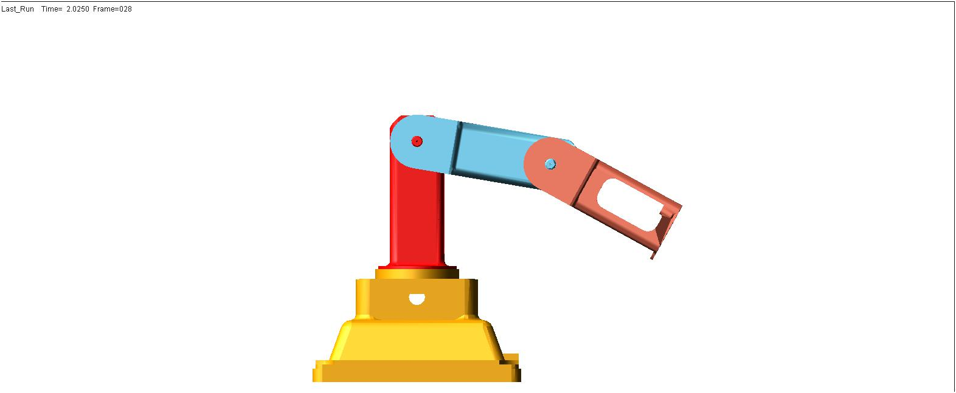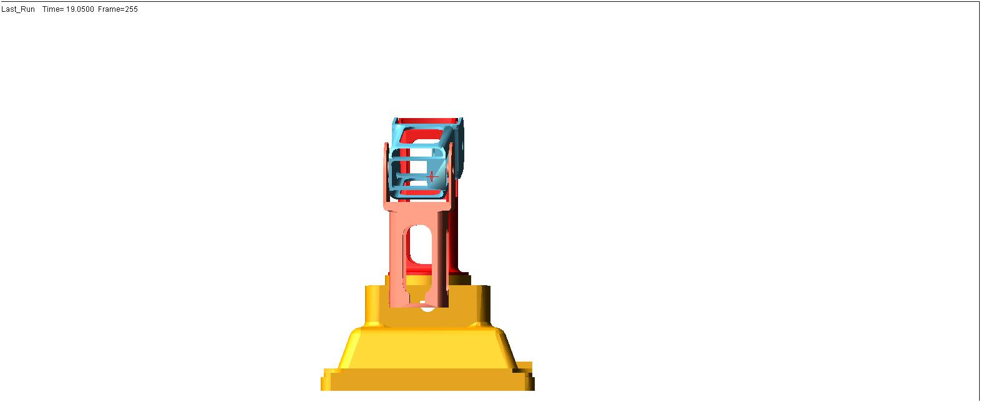

(a) (b) (c)
Figure 5 (a), (b) and (c): Initial and end position of the robot on a defined path during
dynamic analysis

(a) (b)

Figure 5 (a) and (b): End point velocities of the robot

Motor torques at each joint arecalculated for the movement of the robot. Angular velocity data obtained from kinematic analysis are used for kinetic calculations. Kinetic analysis is then performed with same trajectories,whereas angular velocities are considered as input values. Axes torquesisrequired for desired motion are seen in Figure 6.

(a) (b) (c)
Figure 6: Angular velocity of the robot axes, (a) first axis, (b) second axis, (c) third axis
4. Conclusion
The aim of this research work was to incorporate CAD-based analysis method in kinematic design assurance of robotic system. Effectiveness of CAE systems was enabled to reduce of process development time. Here one CAD programme was utilized for static analysis, stress and frequency distribution and another was approached for kinematic motion, position computation and dynamic simulation also. Considerable production time and inertia forces had been reduced by quick movements of links of robot. Not only that, importance of the trajectory path selection and its effects on the dynamic response was depicted during strain measurements stress analyses performed in simulated environment.
First model of the robot could not ensure the static analysis requirements. The first model was improved by making some modifications. It is possible to claim that CAD and CAE systems integrated into the same CAE system are very powerful tools for effectiveness making of the designers work. Therefore, although static and dynamic behavior of the manipulator could be predicted through the numerical analyses, the analytical results which were derived in this paper had implied accurate robot manipulators design by using today’s CAE tools.
Reference
[1] J. Craig, “Introduction to Robotics”, 1986.
[2] Thomson, C.C., 1984. Robot modeling-the tools needed for optimal design and Utilization. Computer-Aided Design, 16(6): 335-337
[3] Vukobratovic, M., V. Potkonjak, K. Inoue, M. Takano, 2002. Actuators and Computer- aided design of robots. Nwokah, O.D.I.(Ed.). Mechanical systems design Handbook, pp: 523-556.
[4] Mir-Nasiri, N., 2004. Design, modeling and control of four-axis parallel robotic arm for assembly operations. Assembly Automation, 24(4): 365-369.
[5] Clark. S, Y.J. Lin, 2007. CAD tools integration for robot kinematics Design assurance with case studies on PUMA robots. Industrial Robot, 2007:34(3): 240-248.
[6] Chang-Soo Han, Alfred E. Traver & Delbert Tesar “Using CAD/CAM in the design of a robotic micromanipulator”, The University of Texas at Austin, Computer-Aided Engineering Journal, April 1990.
[7] Abdel-Malek K., Paul. B, “Criteria for the design of manipulator arms for a high stiffness to weight ratio”, SME journal of manufacturing systems, 17, 209-220(3) 1998.
[8] Kunwoo Lee, Daniel A. Tortorelli, “A CAD System For Designing Robotic Manipulators”, IEEE Publication, 1985.
[9] Karagülle, H. & Malgaca, L., “Analysis of end point vibrations of a two-link manipulator by integrated CAD/CAE procedures”. Finite elements in analysis and design, 40, 2049-2061, 2004.
[10] K. Park, Y.S. Kim, C.S. Kim & H.J. Park, “Integrated application of CAD/CAM/CAE and RP for rapid development of a humanoid biped robot”, Journal of materials processing technology, 187-188, 609-6.13, 2007.
[11] J. Ramirez A. and A. Rubiano F, “Optimization of inverse kinematics of a 3R robotic manipulator using genetic algorithms”, World academy of science engineering and technology, 59, 2011.
[12] K. Jayarajan, D.D. Ray and Manjit Singh, “Advanced Servo Manipulator: A Milestone in Remote Handling Technology”, Division of remote handling and robotics, Issue no. 283, August 2007, BARC.
[13] Dar-Zen Chen, “Drive train configuration arrangement for gear coupled manipulators”, Journal of robotic systems 14(8), 601–612 (1997).

